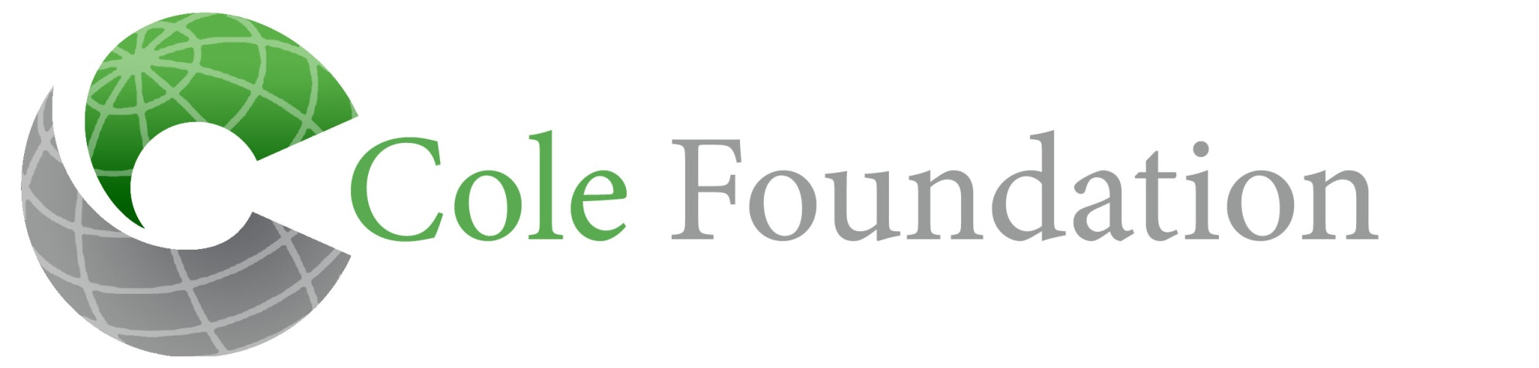
Bringing Hope, Transforming Lives

EXCLUSIONS FROM GRANT FUNDING

The Cole Foundation would be honored to help you with all your healthcare needs; however, there must be limits for all sources of funding. The following list is items/services that are “exclusions”. Exclusions are items/services that the Cole Foundation DOES NOT consider for funding. The Cole Foundation will NOT pay for these services even if your physician recommends the items/services. Please indicate by your signature at the bottom of this form that you understand that these services will not be included in the funding from the Cole Foundation.

Exclusions Include:
- Dental or orthodontic treatment.
- Any pharmaceutical items or drugs.
- Vehicles (cars, vans, trucks, etc.)
- Transportation
- Service dogs or other animal/pets.
- Biofeedback
- Biomedical consultations
- Chelation therapy
- Heavy metal toxicity testing
- Hyperbaric oxygen treatment
- Herbal treatment or testing
- Relationship Development Intervention (RDI)
- Any forms of reproduction, including, but not limited to infertility testing or drugs, pregnancy testing or treatment, birthing
- Other exclusions: Autopsy, burial costs, funeral costs, clinical trials.

________________________________________________
Applicant’s Signature or Parent’s Signature

________________________________________________
Applicant’s Printed Name

________________________
Date

